**Import Random Image from Image Directory:**

import os

import random

import cv2

import matplotlib.pyplot as plt

def select_random_image_from_folder(folder_path):

    # Verify if the folder exists

    if not os.path.exists(folder_path):

        raise FileNotFoundError(f"The folder path {folder_path} does not exist.")

    # Get a list of all files in the folder

    files = os.listdir(folder_path)

    # Filter out only image files (optional step)

    image_files = [f for f in files if f.lower().endswith(('png', 'jpg', 'jpeg', 'bmp', 'gif', 'tiff'))]

    if not image_files:

        raise FileNotFoundError(f"No image files found in the folder {folder_path}.")

    # Select a random image

    random_image = random.choice(image_files)

    # Load the selected image

    image_path = os.path.join(folder_path, random_image)

    image = cv2.imread(image_path)

    return image, random_image

# Example usage

folder_path = r"F:\Bird_Data\Bird\images\train"  # Replace with your absolute folder path

image, image_name = select_random_image_from_folder(folder_path)

# Display the randomly selected image

image_rgb = cv2.cvtColor(image, cv2.COLOR_BGR2RGB)

plt.figure(figsize=(10, 10))

plt.imshow(image_rgb)

plt.title(f"Randomly Selected Image: {image_name}")

plt.axis('off')

plt.show()

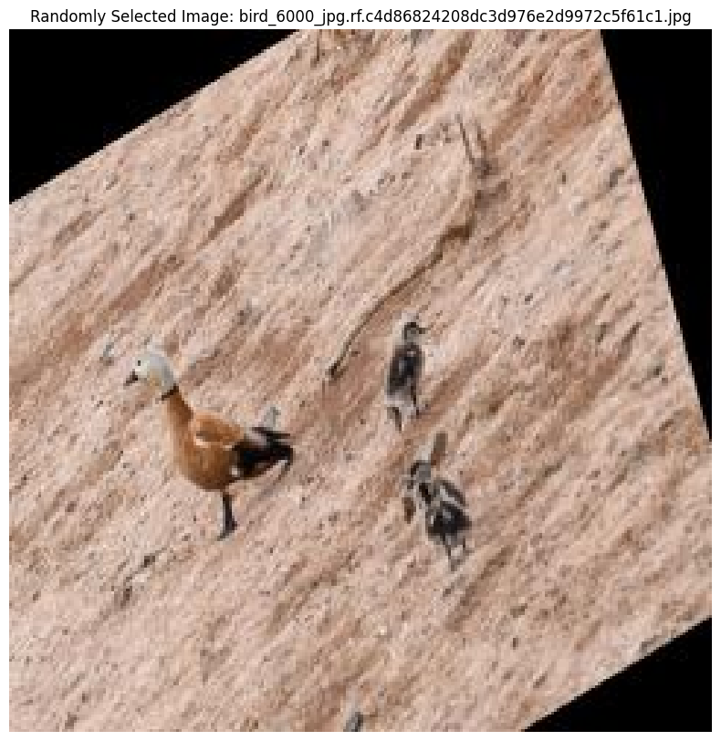

**Load TFlite model**

import numpy as np

import tensorflow as tf

import matplotlib.pyplot as plt

# Load TFLite model and allocate tensors

interpreter = tf.lite.Interpreter(model_path=r"F:\Bird_Data\Bird\trained_models\newModel\my_model.tflite")

interpreter.allocate_tensors()

# Get input and output tensors

input_details = interpreter.get_input_details()

output_details = interpreter.get_output_details()

**Run Inference on Randomly selected image**

import cv2

import numpy as np

def run_inference_tflite(interpreter, image):

    # Get input details

    input_details = interpreter.get_input_details()

    # Resize the image to the expected input size

    input_shape = input_details[0]['shape']

    height, width = input_shape[1], input_shape[2]

    resized_image = cv2.resize(image, (width, height))

    # Preprocess the image

    input_data = np.expand_dims(resized_image, axis=0).astype(np.float32)

    # Set the input tensor

    interpreter.set_tensor(input_details[0]['index'], input_data)

    # Run inference

    interpreter.invoke()

    # Get output details

    output_details = interpreter.get_output_details()

    # Extract predictions

    bbox_pred = interpreter.get_tensor(output_details[1]['index'])

    class_pred = interpreter.get_tensor(output_details[0]['index'])

    return bbox_pred[0], class_pred[0]

# Example: Running inference on the first test image

bbox_pred, class_pred = run_inference_tflite(interpreter, image)

**Visualize the prediction:**

def visualize_tflite_output(image, bbox, class_pred, class_names):

    # Denormalize the bounding box

    h, w, _ = image.shape

    x_min, y_min, x_max, y_max = bbox

    x_min = int(x_min * w)

    y_min = int(y_min * h)

    x_max = int(x_max * w)

    y_max = int(y_max * h)

    # Plot the image

    plt.figure(figsize=(8, 8))

    plt.imshow(cv2.cvtColor(image, cv2.COLOR_BGR2RGB))

    # Plot the bounding box

    plt.gca().add_patch(plt.Rectangle((x_min, y_min), x_max - x_min, y_max - y_min,

                                      edgecolor='red', facecolor='none', linewidth=2))

    # Plot the label

    label_idx = np.argmax(class_pred)  # Get the index of the class

    class_name = class_names[label_idx]

    plt.text(x_min, y_min - 10, class_name, color='red', fontsize=12, weight='bold')

    plt.axis('off')

    plt.show()

# Visualize the result

visualize_tflite_output(image, bbox_pred, class_pred, class_names={0: 'SuperBird', 1: 'Bird', 2: 'Background'})

